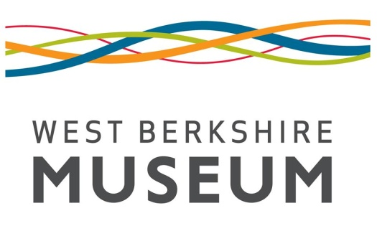
West Berkshire Museum
The Wharf, Newbury, RG14 5AS
Tel 01635 30511
museum@westberks.gov.uk
www.westberkshiremuseum.org.uk
Notification of Fieldwork
Depositor Name: | Site Name:
Address: | Site Address:
Site Manager/Main Contact: | Parish:
Tel: | Site Code:
Email: | Grid Reference:
Planning Reference Number: | OASIS Record ID:

Start Date: | Expected Deposition Date:

Type of Fieldwork: (please delete) | Evaluation / trenching / watching brief / field walking / excavation / survey / building recording
Type of site expected: (please delete) | Prehistoric / Roman / Medieval / Post-Medieval / Modern
Quantity of boxes expected: (please delete)  Paper Archive: 1 / 2-5 / >5  Finds Archive: <5 / 5-20 / >20 | Waterlogged material anticipated? Y/N  Conservation problems anticipated? Y/N

TO BE COMPLETED BY MUSEUM
Museum Accession Number:  NEBYM: | Archaeology Event Record Number:  EWB
Signed for Museum:

Date:
Contract forwarded? Y/N | Signed contract returned? Y/N

TO BE COMPLETED BY DEPOSITOR
Number of Paper Archive Boxes: | Itemised Box List? Y/N
Number of Finds Boxes: | ToT for Paper Archive? Y/N
Number of Stewart Boxes: | ToT for Finds Archive/Landowner Consent Letter? Y/N/NA
Number of Plan Rolls: | Digital Archive Included? Y/N
Number of Unboxed Finds: | Security Copy Included? Y/N
Signed for Depositor:

Date:

TO BE COMPLETED BY MUSEUM
Charge: | Archive Received in Satisfactory State:  Signed for Museum:  Date:
Invoice Sent: (date)
Paid/agreed: (date)

